

TALLINN UNIVERSITY OF TECHNOLOGY

SCHOOL OF ENGINEERING

MECHATRONICS AND AUTONOMOUS SYSTEMS CENTRE

**Design and Implementation of a Secure and Cost-effective Robotized Drone Positioning System**

**Robotiseeritud droon-positsioneerimissüsteemi disain ja rakendus**

MASTER THESIS

|  |  |
| --- | --- |
| Student: | Georgios Tymbakianakis |
|  | |
| Student code: | 184671MAHM |
| Supervisor: | Prof. Mart Tamre |
|  | |

**AUTHOR’S DECLARATION**

Hereby I declare, that I have written this thesis independently.

No academic degree has been applied for based on this material. All works, major viewpoints and data of the other authors used in this thesis have been referenced.

“.......” .................... 201…..

Author: ..............................

/signature /

Thesis is in accordance with terms and requirements

“.......” .................... 201….

Supervisor: ….........................

/signature/

Accepted for defence

“.......”....................201… .

Chairman of theses defence commission: ...........................................................

/name and signature/

# Contents

Contents 2

PREFACE 4

PREFACE IN ESTONIAN LANGUAGE 5

INTRODUCTION 6

1. LITERATURE OVERVIEW/ANALYSIS 7

1.1. Existing Solutions 7

1.2. Thesis Objective 8

1.3. Research Objective 8

1.4. Scope of Thesis 8

1.5. Organization of Thesis 9

2. MACHINE VISION 11

2.1. Design 11

2.2. Implementation 11

3. COORDINATE TRANSFORMATION 12

3.1. Design 12

3.2. Implementation 12

4. MECHANICAL DESIGN 13

4.1. DESIGN 13

4.2. IMPLEMENTATION 13

5. FINAL IMPLEMENTATION 14

6. TESTING 15

7. CONCLUSION 16

# PREFACE

# PREFACE IN ESTONIAN LANGUAGE

# INTRODUCTION

An unmanned aerial vehicle (UAV) is an aircraft without a human pilot on board and can also be referred to as a Drone. UAVs are a component of an unmanned aircraft system; which include a UAV, a ground-based controller, and a system of communications between the two. The first recorded UAV was the used for the Austrian incendiary balloon attack on Venice in 1849(Figure 1).

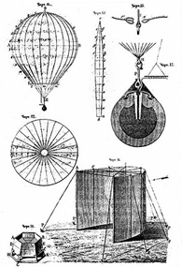

Figure 1 Austrian incendiary balloon attack on Venice

The flight of UAVs may operate with various degrees of autonomy: either under remote control by a human operator or autonomously by onboard computers. UAVs usage has gathered significant attention the past decade especially after the latest improvements in flight stability control [1] and composite materials allowing us the design and manufacturing of lightweight composite frames with high structural efficiency [2]. We have reached a point where Drones, with fully automated flying capabilities, weigh less that 5 kg (Figure 2).

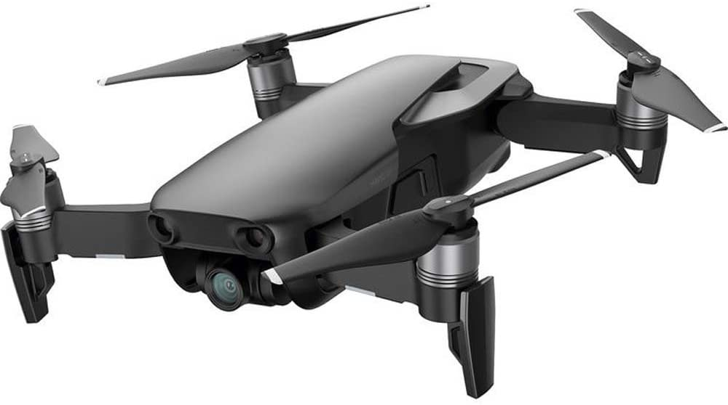

Figure 2 DJI Mavic Air

One area, were UAVs have found growing grounds is the package delivery system where companies employ the use of drones to deliver payloads in an autonomous manner. The advances in this field the past years are extraordinary, and we have managed to address task scheduling and path planning problems, for a team of cooperating UAVs performing autonomous deliveries in urban environments [3]. That has allowed companies, like Amazon, to implement small networks of automated drone delivery services where a UAV caries a payload and either deposits its payload close to the target area or on a specialized area where it is collected and processed by the company’s personnel. The challenges associated with automated drone delivery systems arise from the need for maintenance and accuracy of landing as well as the development of solutions for vehicle routing problems (VRPs) specifically for drone delivery scenarios [4]. We have created solutions when it comes to wireless charging [5] and general maintenance however the precision of automated landing systems does not allow us to create a reliable automated drone positioning system in order to combine such solutions.

The recent developments in robotics and machine vision tools have allowed companies to create hardware solutions such as cost-efficient robotic arms and stereoscopic cameras. For example, in Figure 3 we can see that a 5000$ 7DOF robotic arm can cost an order of magnitude less than a similar capability robot of the recent past. Granted, the use case of these 2 robots might be different, the prototyping and proof of concept capabilities are still there. It is in the hand of engineers now to combine all of these different technologies and come up with cost effective solutions to arising problems.

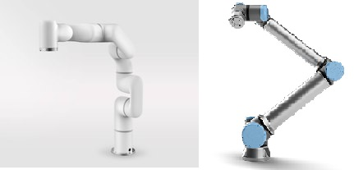

Figure 3 5000$ xArm 6 and 45000$ UR10 Robot

# LITERATURE OVERVIEW/ANALYSIS

## Thesis Objective

The objective of this thesis is to create a system that will employ a robotic arm and a camera or set of cameras, in order to detect a drone with its payload in 3d space. Then after translating its position to mechanical movement, the robot arm will grasp the drone, with the use of its grip, by a custom-made bracket, that will also serve as a reference point. The bracket will incorporate a QR code that will contain the data necessary to implement a cryptographed security system. Finally, the robotic arm will move the drone to a predefined location in a safe manner that will not compromise the structural integrity of the drone and the payload.

## Research Objective

The objective of this research is to design and implement a precise post-landing positioning system that will physically manipulate a UAV, post-landing, in order to position it in such way that its payload can be deposited or retrieved in a desired manner. This will be achieved with the use of a robotic arm and manipulator that will mechanically link to the drone and position in to the desired location. The detection of the drone will be done optically. The system must be universal, meaning that the type of drone used should not affect the performance of the system. The system should also be cost effective and weather proof. Therefore, the result of this thesis will be a HW and SW system that will be able to detect an UAV in 3D space, control a robotic arm in order to mechanically connect with the drone and manipulate it in order to place it in a precise location.

## Existing Solutions

For years, companies such as Amazon and Google have been hard at work developing a safe and practical way of utilizing the potential of unmanned aerial vehicles to improve upon their current network of delivery services. Transportation of even the largest package has become feasible due to the advances in drone-based robotics. The biggest problem left unanswered is how to best release the pay load once the drone has arrived at the drop off location. Crude solutions have been achieved such as a basket that can hold onto the package until the drone is rapidly flipped upside down in an aerial maneuver (oftentimes called a roll) and the centrifugal force ejects the payload from the basket [6].

The need for accurate payload delivery stems from the problems that arise when we are trying to create automated post-landing payload handling. In other words, after a drone has landed, the payload should be retrieved in a safe manner without compromising or damaging the payload. Such control over the payload retrieval can allow us to further process they payload without human intervention. For example, a drone can deliver a package and the package can be retrieved and loaded in a cargo container [7], since the deposit of they payload will be accurate and there will be no need for human intervention in order to load or transfer the payload.

There are multiple ways to ensure an accurate landing position including the use of GPS systems and on-board sensors [8] but there is a need for off-board and universal precise landing systems that could support a multitude of different drones and be a “plug and play” solution.

The advances in Machine Vision and Machine Learning technology is a vital tool for creating such robust payload delivery platforms. Since UAVs undoubtedly pose several threats to airspace safety that may endanger people and property, several drone-detecting techniques have been developed the past years [9] however optical detection remains a cost-effective way to detect an object, in this case a drone. Recent developments in object detection algorithms also provide powerful tools with which we can tackle drone postlanding positioning problems [10].

## Scope of Thesis

This thesis will explore 3 main research areas for which several problems should be solved in order to reach a novel solution.

First area is the Machine Vision and object detection in 3D space where with the use of a camera or combination of cameras we will be called to create an algorithm that will reliably detect our desired object in 3D space. We will have to decide where to mount the camera and the primary solution should be on the end of the robotic arm. Several options will be investigated before we reach a conclusion of the camera placement. The desired object will be a marker on the drone that will indicate an origin point for the system. This will require the exploration of a multitude of object detection techniques such as Region Shrinking [10] Stereoscopic imaging [11] [12]or Object Pruning [13]. In this context we will try to employ already existing techniques for optical detection [14] while adapting and possibly creating our own algorithm for object detection. Previous solutions regarding picking and placing of objects with they use of a robotic arm have been found [15] [16] [17] [18] but in this case we need the tracking of the object to be dynamic and we need the system to adapt to changes such as a sudden change in the objects position due to weather conditions.

Second research area is Coordinate translation. After we manage to detect our object in 3D space, we will use the computer vision input to calculate the motor positions of the joints’ in order to reach the desired object and grasp it. This is where the technique of choice for the object detection will determine how we will tackle this problem. If we use a stereoscopic imaging technique, one camera is enough to make the movement on the X and Y coordinate systems, but for movement the third dimension we need a second camera to move on the Z coordinate too. We will also investigate if forward or inverse kinematics is a viable option even though the magnitude of mathematical calculation involved is proven to be immense [19]. We will also explore the possibility of converting pixel coordinates into real world coordinates with the help of 2D transformation [20].

The third research area is the Mechanical Engineering part where we would need to explore different techniques to mechanically connect the drone to the robotic arm. The engineering of a bracket that the manipulator will grapple will prove tricky since it should not impede normal drone operation and it should be universal for all types of UAVs. We will experiment with different types of composites and conclude to a cost-effective way to engineer such bracket.

## Outline

The thesis main body will be split into the 4 chapters. Each research area will have a separate chapter where a solution will be found. Chapter 2 for the Machine Vision solution, Chapter 3 for the Coordinate Translation solution and Chapter 4 for the Mechanical Engineering of the bracket. Chapter 5 will describe the combination of the solutions in order to achieve the desired effect and Chapter 6 will analyse testing of the system. A final Chapter 7 will be used to summarize our conclusions, limitations and suggestions for further improvement as well as the future scope of this research.

Ultimately the thesis will contain 7 Chapters structured as seen below:

* Chapter 1: Introduction
  + Overview
  + Research Objective
  + Scope of thesis
  + Organisation of Thesis
* Chapter 2: Machine Vision
  + Design
  + Implementation
* Chapter 3: Coordinate Transformation
  + Design
  + Implementation
* Chapter 4: Mechanical Design
  + Design
  + Implementation
* Chapter 5: Final Implementation
* Chapter 6: Testing
* Chapter 7: Conclusion

# MACHINE VISION

DLT Calibration

## Design

## Implementation

# COORDINATE TRANSFORMATION

## Design

## Implementation

# MECHANICAL DESIGN

## DESIGN

## IMPLEMENTATION

# FINAL IMPLEMENTATION

# TESTING

# CONCLUSION

BIBLIOGRAPHY

|  |  |
| --- | --- |
| [1] | X. Huang and X. Hu, "Orthogonal design and optimization of flight stability test for the quadrotor unmanned aerial vehicle," *2017 IEEE International Conference on Unmanned Systems (ICUS) Beijing,* pp. 343-346, 2017. |
| [2] | T. Costa, M. Caldas, P. Araujo and E. Silva, "Topological Optimization applied towards the development of a small and lightweight MAV composite frame," 2018. |
| [3] | N. Mathew, S. L. Smith and S. L. Waslander, "Planning Paths for Package Delivery in Heterogeneous Multirobot Teams," *IEEE Transactions on Automation Science and Engineering,* vol. 12, no. 4, pp. pp. 1298-1308, 2015. |
| [4] | K. Dorling, J. Heinrichs, G. G. Messier and S. Magierowsk, "Vehicle Routing Problems for Drone Delivery," *IEEE Transactions on Systems, Man, and Cybernetics: Systems,* vol. 47, no. 1, pp. 70-85, 2017. |
| [5] | S. Tansuriyong, M. Kyan, K. Numata, S. Taira and T. Anezaki, "Verification experiment for drone charging station using RTK-GPS," in *2017 International Conference on Intelligent Informatics and Biomedical Sciences (ICIIBMS)*, Okinawa, 2017. |
| [6] | C. Burke, H. Nguyen, M. Magilligan and R. Noorani, "Study of A Drone’s Payload Delivery Capabilities Utilizing Rotational Movement," in *2019 International Conference on Robotics,Electrical and Signal Processing Techniques (ICREST)*, Dhaka, 2019. |
| [7] | D. Shneider, "The delivery frones are coming," *IEEE Spectrum,* vol. 1, no. 57, pp. 28-29, 2020. |
| [8] | Jiang, T. Zhao and Hong, "Landing system for AR.Drone 2.0 using onboard camera and ROS," in *2016 IEEE Chinese Guidance, Navigation and Control Conference (CGNCC)*, Nanjing, 2016. |
| [9] | B. Shoufan and A. Taha, "Machine Learning-Based Drone Detection and Classification: State-of-the-Art in Research," *IEEE Access,* vol. 7, no. 1, pp. pp. 138669-138682, 2019. |
| [10] | Z. Li, H. Liu and D. Sun, "Moving object detection and locating based on region shrinking algorithm," in *2012 IEEE International Conference on Mechatronics and Automation*, Chengdu, 2012. |
| [11] | X. Chen, K. Kundu, Y. Zhu, H. Ma, S. Fidler and R. Urtasun, "3D Object Proposals Using Stereo Imagery for Accurate Object Class Detection," *IEEE Transactions on Pattern Analysis and Machine Intelligence,* vol. 40, no. 5, pp. 1259-1272, 2018. |
| [12] | G. Luo, M. Cheng and C. Chiang, "Vision-based 3-D object pick-and-place tasks of industrial manipulator," in *2017 International Automatic Control Conference (CACS)*, Pingtung, 2017. |
| [13] | J. Liu, H. Chen and J. Li, "Faster 3D Object Detection in RGB-D Image Using 3D Selective Search and Object Pruning," in *2018 Chinese Control And Decision Conference (CCDC)*, Shenyang, 2018. |
| [14] | N. A. Abramov, M. V. Bolsunovskaya, A. V. Leksashow and D. S. Barinov, "Algorithms for detecting and tracking of objects with optical markers in 3D space," in *2016 XIX IEEE International Conference on Soft Computing and Measurements (SCM)*, St. Petersburg, 2016. |
| [15] | R. Yenorkar and U. M. Chaskar, "GUI Based Pick and Place Robotic Arm for Intelligent Computing and Control Systems," in *2018 Second International Conference on Intelligent Computing and Control Systems (ICICCS)*, Madurai, 2018. |
| [16] | M. Farag, A. N. A. Ghafar and M. H. Alsibai, "Grasping and Positioning Tasks for Selective Compliant Articulated Robotic Arm Using Object Detection and Localization: Preliminary Results," in *2019 6th International Conference on Electrical and Electronics Engineering (ICEEE)*, Istanbul, 2019. |
| [17] | R. Kumar, S. K. S. Lal and P. Chand, "Object detection and recognition for a pick and place Robot," in *Asia-Pacific World Congress on Computer Science and Engineering*, Nadi, 2014. |
| [18] | S. A. Khan, T. Z. Anika, N. Sultana, F. Hossain and M. N. Uddin, "Color Sorting Robotic Arm," in *2019 International Conference on Robotics,Electrical and Signal Processing Techniques (ICREST)*, Dhaka, 2019. |
| [19] | R. S. a. A. Gontean, "Controlling a robotic arm in the 3D space with stereo vision," in *21st Telecommunications Forum Telfor (TELFOR)*, Belgrade, 2013. |
| [20] | P. Andhare and S. Rawat, "Pick and place industrial robot controller with computer vision," in *2016 International Conference on Computing Communication Control and automation*, Pune, 2016. |
| [21] | R. Gontean and A. Szabó, "Controlling a robotic arm in the 3D space with stereo vision," in *21st Telecommunications Forum Telfor (TELFOR)*, Belgrade, 2013. |